**CampusLearn Deployment Specification Document**

**1. Executive Summary**

This document outlines the deployment strategy for CampusLearn, a comprehensive educational platform designed for Belgium Campus. The specification covers infrastructure, hosting, maintenance, and scaling strategies.

**2. Hosting Environment and Infrastructure Setup**

**2.1 Recommended Cloud Infrastructure: Microsoft Azure**

Given Belgium Campus's likely existing Microsoft ecosystem, we will make use of  **Microsoft Azure** as the primary hosting platform.

**2.2 Architecture Overview**

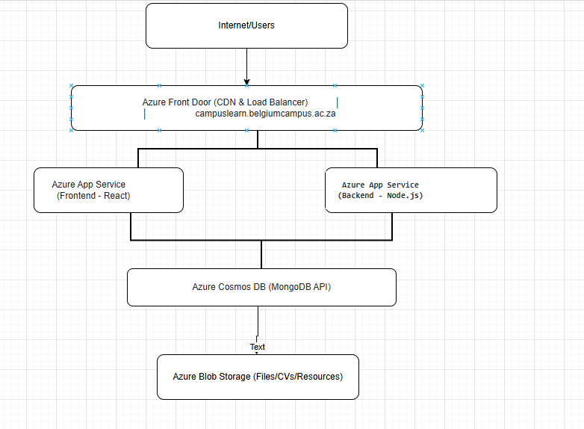

**2.3 Detailed Infrastructure Components**

**2.3.1 Compute Instances**

**Frontend Hosting - Azure App Service**

YAML

Service: Azure App Service

Plan: Standard S1

Instances: 2 (for high availability)

OS: Linux

Runtime: Node.js 18 LTS

Location: South Africa North (Johannesburg)

Auto-scaling: Enabled (2-4 instances based on load)

**Backend API - Azure App Service**

YAML

Service: Azure App Service

Plan: Standard S2

Instances: 2 (for high availability)

OS: Linux

Runtime: Node.js 18 LTS

Location: South Africa North (Johannesburg)

Auto-scaling: Enabled (2-5 instances based on load)

Memory: 3.5 GB per instance

CPU: 2 vCPU per instance

**2.3.2 Database Configuration**

**Primary Database - Azure Cosmos DB**

YAML

Service: Azure Cosmos DB for MongoDB

Capacity Mode: Autoscale

Maximum RU/s: 4000

Minimum RU/s: 400

Replication: Multi-region (Johannesburg primary, Cape Town secondary)

Backup: Continuous backup with 30-day retention

Consistency Level: Session consistency

**2.3.3 Storage Configuration**

**File Storage - Azure Blob Storage**

YAML

Service: Azure Blob Storage

Account Type: Standard LRS (Locally Redundant Storage)

Containers:

- user-profiles (profile pictures)

- cv-documents (tutor CVs)

- course-resources (learning materials)

- assignments (student submissions)

Access Tier: Hot (frequently accessed)

Backup: Geo-redundant backup enabled

CDN Integration: Yes, via Azure Front Door

**2.3.4 Domain and DNS Configuration**

**Domain Structure:**

text

Primary Domain: campuslearn.belgiumcampus.ac.za

API Endpoint: api.campuslearn.belgiumcampus.ac.za

CDN/Assets: cdn.campuslearn.belgiumcampus.ac.za

Admin Portal: admin.campuslearn.belgiumcampus.ac.za

**DNS Configuration (Azure DNS):**

dns

A Records:

campuslearn.belgiumcampus.ac.za → Azure Front Door IP

api.campuslearn.belgiumcampus.ac.za → App Service IP

CNAME Records:

www.campuslearn.belgiumcampus.ac.za → campuslearn.belgiumcampus.ac.za

cdn.campuslearn.belgiumcampus.ac.za → Azure CDN endpoint

MX Records:

For email notifications via Office 365

**2.3.5 Load Balancing and CDN**

**Azure Front Door Configuration:**

YAML

Service: Azure Front Door

Tier: Standard

Features:

- Global load balancing

- SSL/TLS termination

- WAF (Web Application Firewall) enabled

- Caching for static assets

- Health probes every 30 seconds

- Automatic failover

Routing Rules:

- / → React Frontend App Service

- /api/ → Node.js Backend App Service

- /uploads/ → Azure Blob Storage

Caching Rules:

- Static assets (JS, CSS): 7 days

- Images: 30 days

- API responses: No cache (except GET /api/courses)

**2.4 Security Infrastructure**

**Azure Key Vault:**

YAML

Purpose: Secure storage of secrets and certificates

Contents:

- Database connection strings

- JWT secrets

- API keys

- SSL certificates

Access Policy: Managed Identity for App Services

**Network Security:**

YAML

Virtual Network: CampusLearn-VNet

Subnets:

- Frontend-Subnet: 10.0.1.0/24

- Backend-Subnet: 10.0.2.0/24

- Database-Subnet: 10.0.3.0/24

Network Security Groups:

- Allow HTTPS (443) from Internet to Frontend

- Allow HTTP (80) redirect to HTTPS

- Backend accessible only from Frontend subnet

- Database accessible only from Backend subnet

**2.5 Environment Configuration**

**Development Environment:**

YAML

Location: Local development machines

Database: MongoDB Atlas (Free tier)

Storage: Local file system

Domain: localhost:5173 (frontend), localhost:5000 (backend)

**Staging Environment:**

YAML

Location: Azure (shared resources)

Database: Azure Cosmos DB (Development tier)

Storage: Azure Blob Storage (Development)

Domain: staging-campuslearn.belgiumcampus.ac.za

Purpose: UAT and testing

**Production Environment:**

YAML

Location: Azure South Africa North

Database: Azure Cosmos DB (Production tier)

Storage: Azure Blob Storage (Production)

Domain: campuslearn.belgiumcampus.ac.za

Purpose: Live system for all users

**2.6 Deployment Pipeline**

**CI/CD using Azure DevOps:**

YAML

Source Control: GitHub

Build Pipeline:

- Trigger: Push to main branch

- Steps:

1. Run tests

2. Build React app

3. Build Node.js app

4. Create Docker images

5. Push to Azure Container Registry

Release Pipeline:

- Staging Deployment:

- Automatic on successful build

- Run integration tests

- Require approval for production

- Production Deployment:

- Manual approval required

- Blue-green deployment strategy

- Automatic rollback on failure

**2.7 Monitoring and Logging**

**Azure Application Insights:**

YAML

Features:

- Real-time performance monitoring

- Error tracking and alerts

- User session tracking

- Custom metrics for business KPIs

Alerts:

- Response time > 2 seconds

- Error rate > 1%

- Database connection failures

- Storage quota > 80%

**2.8 Backup and Disaster Recovery**

**Backup Strategy:**

YAML

Database Backup:

- Frequency: Every 4 hours

- Retention: 30 days

- Geo-redundant: Yes

File Storage Backup:

- Frequency: Daily

- Retention: 90 days

- Geo-redundant: Yes

Application Backup:

- Version control: Git

- Container images: Azure Container Registry

- Infrastructure as Code: ARM templates

**Disaster Recovery Plan:**

YAML

RTO (Recovery Time Objective): 4 hours

RPO (Recovery Point Objective): 4 hours

Failover Process:

1. Automatic failover to Cape Town region

2. DNS update (TTL: 5 minutes)

3. Database failover to secondary replica

4. Notification to administrators

**2.9 Cost Estimation (Monthly)**

YAML

Azure App Service (Frontend): R 1,500

Azure App Service (Backend): R 2,500

Azure Cosmos DB: R 3,000

Azure Blob Storage: R 500

Azure Front Door: R 1,000

Azure DNS: R 100

Backup and DR: R 800

Monitoring: R 400

------------------------

Total: R 9,800/month (approximately), otherwise free when we use the student version or account. The student version will come with fewer benefits and limited resources

**2.10 Alternative: On-Premises Deployment**

For Belgium Campus internal servers:

**Hardware Requirements:**

YAML

Web Servers:

- 2x Dell PowerEdge R440

- CPU: Intel Xeon Silver 4210 (10 cores)

- RAM: 32GB

- Storage: 2x 1TB SSD (RAID 1)

Database Server:

- 1x Dell PowerEdge R540

- CPU: Intel Xeon Silver 4214 (12 cores)

- RAM: 64GB

- Storage: 4x 2TB SSD (RAID 10)

Load Balancer:

- F5 BIG-IP or HAProxy

- Virtual appliance or hardware

**Software Stack:**

YAML

OS: Ubuntu Server 22.04 LTS (Campus is currently running on Ubuntu as well)

Web Server: Nginx (reverse proxy)

Application Runtime: Node.js 18 LTS with PM2

Database: MongoDB Community Edition

Backup: Veeam or Acronis

Monitoring: Prometheus + Grafana

**3. Implementation Roadmap**

**Phase 1 (Week 1-2):** Development environment setup  
**Phase 2 (Week 3-4):** Azure infrastructure provisioning  
**Phase 3 (Week 5-6):** Application deployment to staging  
**Phase 4 (Week 7-8):** Testing and optimization  
**Phase 5 (Week 9-10):** Production deployment  
**Phase 6 (Ongoing):** Monitoring and maintenance

**4. Conclusion**

This deployment specification provides a robust, scalable, and secure infrastructure for CampusLearn. The Azure-based solution offers high availability, automatic scaling, and comprehensive disaster recovery while maintaining cost-effectiveness for an academic institution.